TYPES OF BACKUP: FULL, INCREMENTAL, DIFFERENTIAL AND MIRROR

There are several different types of backup. Here's how to choose the best way to safeguard your data and recover appropriately in the event of an incident.

**Full backups**

The most basic and complete type of backup operation is a full backup. As the name implies, this type of backup makes a copy of all data to another set of media, such as a disk or tape.

**Advantage** to performing a full backup during every operation is that a complete copy of all data is available with a single set of media. This results in a minimal time to restore data,

**Disadvantages** are that it takes longer to perform a full backup than other types (sometimes by a factor of 10 or more), and it requires more storage space.

**Incremental backups**

An [incremental backup](https://searchdatabackup.techtarget.com/definition/incremental-backup) operation will result in copying only the data that has changed since the last backup operation of any type. An organization typically uses the modified time stamp on files and compares it to the time stamp of the last backup. Backup applications track and record the date and time that backup operations occur in order to track files modified since these operations.

Because an incremental backup will only copy data since the last backup of any type, an organization may run it as often as desired, with only the most recent changes stored.

**Advantage**: The benefit of an incremental backup is that it copies a smaller amount of data than a full. Thus, these operations will complete faster, and require less [media to store the backup](https://searchdatabackup.techtarget.com/tip/How-to-keep-physical-backup-media-storage-safe).

**Differential backups**

A [differential backup](https://searchdatabackup.techtarget.com/definition/differential-backup) operation is similar to an incremental the first time it is performed, in that it will copy all data changed from the previous backup. However, each time it is run afterwards, it will continue to copy all data changed since the previous full backup. Thus, it will store more data than an incremental on subsequent operations, although typically far less than a full backup. Moreover, differential backups require more space and time to complete than incremental backups, although less than full backups.

**Mirror backups**

A mirror backup is comparable to a full backup it creates an exact copy of the source data set, but only the latest data version is stored in the backup repository with no track of different versions of the files. The backup is a mirror of the source data, thus the name. All the different backed up files are stored separately, like they are in the source.

**Advantage**

One of the benefits of mirror backup is a fast recovery time. It's also easy to access individual backed up files.

**Drawbacks** - 1. More storage space required. With that extra storage, organizations should be wary of cost increases and maintenance needs.

2. If there's a problem in the source data set, such as a corruption or deletion, the mirror backup experiences the same.

One specific kind of mirror, [disk mirroring](https://searchstorage.techtarget.com/definition/disk-mirroring), is also known as RAID 1. This process replicates data to two or more disks. Disk mirroring is a strong option for data that needs high availability because of its quick recovery time. It's also helpful for disaster recovery because of its immediate failover capability. Disk mirroring requires at least two physical drives. If one drive fails, an organization can use the mirror copy. While disk mirroring offers comprehensive data protection, it requires a lot of storage capacity.

**Comparison of different types of Backup**

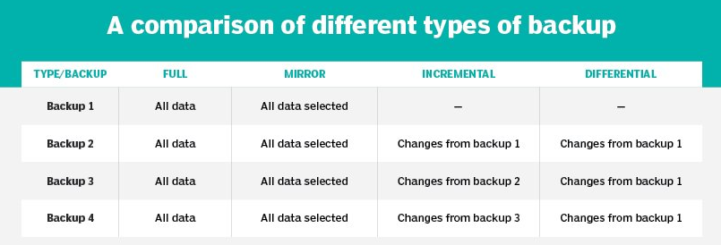

**Best Backup Rules**

Follow the [3-2-1 rule of backup](https://searchdatabackup.techtarget.com/definition/3-2-1-Backup-Strategy), which includes three copies of data on two different media, with one copy off site.